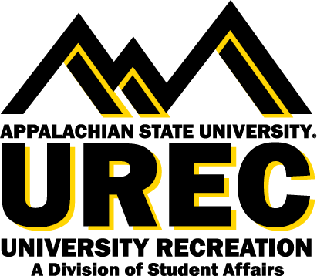

APPALACHIAN STATE UNIVERSITY
University Recreation (UREC)
Fitness Instructor

The Fitness Instructor is primarily responsible for delivering inclusive, active, fun, and engaging Group Fitness classes. The Group Fitness classes will be comprised of one of the following major format categories (cardio, strength, mind/body, dance, and cycle). Fitness Instructors are an essential part of delivering fitness and wellness opportunities to our members as a part of a comprehensive Fitness and Wellness program.

Supervisor: This position reports directly to Graduate Assistant of Fitness and Wellness.
Hours: Fitness Instructor weekly hours will be based on class schedule. Minimum of one class per week.
Salary: $10.50 per hour.

You will succeed at UREC if you are committed to:
- Explore to find the best of you
- Bring your positive and constructive attitude
- Connect with others
- Be a team player
- Embrace and inspire an inclusive, vibrant, active, and healthy community
- Work in a flexible schedule that may require some evenings, weekends, and designated holidays

Join our team
Appalachian State University (App State) invites interested applicants for the position of Fitness Instructor to become a part of the University Recreation (UREC) team as we facilitate an inclusive environment where recreation and wellness opportunities transform, engage, and care for the App State community.

Who we are
UREC fosters healthy lifestyles for lifelong wellbeing. You will join a UREC team that is creating an exciting environment, values collaboration, innovation, and inclusion, and is welcoming to all App State students, faculty and staff. We are creating a risk-taking workplace that supports the voices and contributions of employees at all levels, listens, and responds to our community. At UREC we believe in an equitable UREC community with opportunities for everyone, with everyone. Learn more about us at this link

Responsibilities include, but are not limited to:
- Provide innovative fitness classes to members by providing program information, guidance, demonstration, instruction, and feedback.
- Communicating University Recreation policies and procedures.
- Cultivate a campus culture that appreciates the benefits of an active lifestyle by serving as a positive and friendly role model.
- Lead safe, inclusive, fun, and effective fitness classes according to the assigned schedule.
- Design workout programs based on current research in the exercise and health sciences.
- Be able to teach and modify exercises to a diverse population and fitness levels.
- Maintain knowledge of and uphold facility and program policies and expectations.
- Use both physical and verbal communication to accommodate various learning styles of members.
- Cleaning and organization of all equipment at the conclusion of classes.
- Other duties as assigned.

Required qualifications:
- CPR/AED, First Aid Certification or ability to obtain within 21 days of first day of employment (UREC will provide this training upon hire).
- Successfully pass a fitness audition with the Fitness Leadership team.
- Dedication to University Recreation and a desire to support its Mission, Vision and Values.
- Preference given to individuals who currently hold a valid fitness certification through ACE, NASM, ACSM or similar accrediting organization.

We are committed to facilitate your learning journey and create unique opportunities for your career and self development in the following areas*:
- Self-awareness
- Communication
- Critical Thinking
- Equity, Diversity, and Inclusion
- Leadership
- Professionalism
- Teamwork
- Health & Wellbeing
* Reprinted courtesy of the National Association of Colleges and Employers

How to apply:
- To apply for positions, please visit our website.
- If you would like to speak with someone about employment opportunities, please call (828) 262-2100 or email anthonykr@appstate.edu
Please be aware that to be eligible for student employment with UREC, you must be a current student enrolled at Appalachian State University and in good academic standing.

Office of Disability Resources Accommodations: Appalachian State University is
committed to providing an inclusive experience, accessible learning [and working] environments and equal opportunity to individuals with disabilities in accordance with the Americans with Disabilities Act and Section 504 of the Rehabilitation Act. Individuals needing reasonable accommodations should contact the Office of Disability Resources (828.262.3056 or odr.appstate.edu)

AA/EEO Statement: Appalachian State University is an Affirmative Action/Equal Opportunity Employer. The University does not discriminate in access to its educational programs and activities, or with respect to hiring or the terms and conditions of employment, on the basis of race, color, national origin, religion, sex, gender identity and expression, political affiliation, age,
disability, veteran status, genetic information or sexual orientation.

* This position is available for Federal Work Study *

