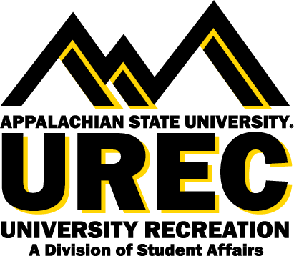

APPALACHIAN STATE UNIVERSITY
University Recreation (UREC)
Bike App Staff Member

The Bike App Staff Member is primarily responsible for bike maintenance and instruction to patrons. Bike App supports the Appalachian State community through education and advocacy for a more sustainable, bike friendly campus and town. Bike App Staff educate and instruct patrons while helping to maintain bicycles.

Supervisor: This position reports directly to the Assistant Director of Outdoor Programs.
Hours: The Bike App Staff Member will work on average 3-12 hours per week during the academic year (up to 35 hours per week during summer sessions).
Salary: $ 8.50 per hour.

You will succeed at UREC if you are committed to:
- Explore to find the best of you
- Bring your positive and constructive attitude
- Connect with others
- Be a team player
- Embrace and inspire an inclusive, vibrant, active, and healthy community
- Work in a flexible schedule that may require some evenings, weekends, and designated holidays

Join our team
Appalachian State University (App State) invites interested applicants for the position of Bike App Staff Member to become a part of the University Recreation (UREC) team as we facilitate an inclusive environment where recreation and wellness opportunities transform, engage, and care for the App State community.

Who we are
UREC fosters healthy lifestyles for lifelong wellbeing. You will join a UREC team that is creating an exciting environment, values collaboration, innovation, and inclusion, and is welcoming to all App State students, faculty and staff. We are creating a risk-taking workplace that supports the voices and contributions of employees at all levels, listens, and responds to our community. At UREC we believe in an equitable UREC community with opportunities for everyone, with everyone. Learn more about us at this link.

Responsibilities include, but are not limited to:
- General maintenance of the facility including general organization and inspection of equipment, inventory, and cleaning.
- Complete Opening and Closing procedures and inspections.
- Promote a safe and equitable environment for all patrons.
- Know and adhere to policies and procedures in order to manage risks and provide quality customer service.
- Notify a supervisor when there is an unusual situation or equipment that needs attention.
- Repair and maintain bicycles and unicycles including:
  - Changing a flat tire
  - Adjusting brakes
  - Adjusting derailleurs
- Teach patrons about bike repairs while helping to maintain/fix their bicycle.
- Teach cycling knowledge including laws related to cycling within the Boone region.
- Maintain basic knowledge of UREC with an ability to effectively communicate this with patrons.
- Be able to complete tasks efficiently and without close supervision.
- Deep cleaning of all equipment throughout shifts worked and especially at specified designated cleaning times.
- Other duties as assigned.
Required qualifications:
- CPR/AED, First Aid Certification or ability to obtain within 21 days of first day of employment (UREC will provide this training upon hire)
- Basic bike maintenance skills (change a flat, adjust brakes, adjust derailleurs) with willingness to learn additional bike maintenance skills.
We are committed to facilitate your learning journey and create unique opportunities for your career and self development in the following areas*:
- Self-awareness
- Communication
- Critical Thinking
- Equity, Diversity, and Inclusion
- Leadership
- Professionalism
- Teamwork
- Health & Wellbeing
* Reprinted courtesy of the National Association of Colleges and Employers

How to apply:
- To apply for positions, please visit our website.
- If you would like to speak with someone about employment opportunities, please call (828) 262-8411 or email norrisjw1@appstate.edu.
Please be aware that to be eligible for student employment with UREC, you must be a current student enrolled at Appalachian State University and in good academic standing.

Office of Disability Resources Accommodations: Appalachian State University is
committed to providing an inclusive experience, accessible learning [and working] environments and equal opportunity to individuals with disabilities in accordance with the Americans with Disabilities Act and Section 504 of the Rehabilitation Act. Individuals needing reasonable accommodations should contact the Office of Disability Resources (828) 262-3056 or odr.appstate.edu.

AA/EEO Statement: Appalachian State University is an Affirmative Action/Equal Opportunity Employer. The University does not discriminate in access to its educational programs and activities, or with respect to hiring or the terms and conditions of employment, on the basis of race, color, national origin, religion, sex, gender identity and expression, political affiliation, age,
disability, veteran status, genetic information or sexual orientation.

* This position is available for Federal Work Study *

