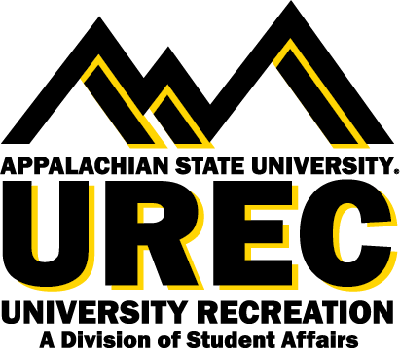

APPALACHIAN STATE UNIVERSITY
University Recreation (UREC)
Swim Instructor

The Swim Instructor is primarily responsible for maintaining constant surveillance of participants in the Appalachian State University swimming pool. Acts immediately and appropriately to secure the safety of participants in the event of emergency. Provides emergency care and treatment as required until the arrival of emergency medical services.

Supervisor: This position reports directly to the Assistant Director for Aquatics.
Hours: The Swim Instructor will work between 8-12 hours per week during the academic year.
Salary: $ 10.50 per hour.

You will succeed at UREC if you are committed to:
- Explore to find the best of you
- Bring your positive and constructive attitude
- Connect with others
- Be a team player
- Embrace and inspire an inclusive, vibrant, active, and healthy community
- Work in a flexible schedule that may require some evenings, weekends, and designated holidays

Join our team
Appalachian State University (App State) invites interested applicants for the position of Swim Instructor to become a part of the University Recreation (UREC) team as we facilitate an inclusive environment where recreation and wellness opportunities transform, engage, and care for the App State community.

Who we are
UREC fosters healthy lifestyles for lifelong wellbeing. You will join a UREC team that is creating an exciting environment, values collaboration, innovation, and inclusion, and is welcoming to all App State students, faculty and staff. We are creating a risk-taking workplace that supports the voices and contributions of employees at all levels, listens, and responds to our community. At UREC we believe in an equitable UREC community with opportunities for everyone, with everyone. Learn more about us at this link

Responsibilities include, but are not limited to:
- Be familiar with American Red Cross Learn-to-Swim levels and other Red Cross water safety courses and know how to use course materials effectively
- Adapt your teaching approaches to the age, experience and ability of participants so they can meet course objectives
- Provide for the health and safety of participants, including ensuring that all teaching and practice areas are free of hazards and that materials and equipment are safe
- Cover all material required in each swim level
- Recognize and respond effectively in emergencies in accordance with facility emergency action plans
- Enforce all aquatic facility policies, rules and regulations
- Complete records and reports
- Participate in regular in-service training sessions
- Complete additional duties as assigned by supervisor
- Other duties as deemed necessary

Required qualifications:
- Preferred, American Red Cross Water Safety Instructor certification
- Past experience as a swim instructor at an aquatic facility
- Thorough knowledge and application of teaching swimming and water safety skills
- Excellent communication skills
- Dedication to University Recreation and a desire to support its mission.
We are committed to facilitate your learning journey and create unique opportunities for your career and self development in the following areas*:
- Self-awareness
- Communication
- Critical Thinking
- Equity, Diversity, and Inclusion
- Leadership
- Professionalism
- Teamwork
- Health & Wellbeing
* Reprinted courtesy of the National Association of Colleges and Employers

How to apply:
- To apply for positions, please visit our website.
- If you would like to speak with someone about employment opportunities, please contact Cheryl Eddins, Assistant Director for Aquatics, (828) 262-8707, or email eddinscj@appstate.edu
Please be aware that to be eligible for student employment with UREC, you must be a current student enrolled at Appalachian State University and in good academic standing.

Office of Disability Resources Accommodations: Appalachian State University is
committed to providing an inclusive experience, accessible learning [and working] environments and equal opportunity to individuals with disabilities in accordance with the Americans with Disabilities Act and Section 504 of the Rehabilitation Act. Individuals needing reasonable accommodations should contact the Office of Disability Resources (828) 262-3056 or odr.appstate.edu.

AA/EEO Statement: Appalachian State University is an Affirmative Action/Equal Opportunity Employer. The University does not discriminate in access to its educational programs and activities, or with respect to hiring or the terms and conditions of employment, on the basis of race, color, national origin, religion, sex, gender identity and expression, political affiliation, age,
disability, veteran status, genetic information or sexual orientation.

* This position is available for Federal Work Study *

